Project Design Phase -1

Solution Architecture

|  |  |
| --- | --- |
| Date | 20 October 2022 |
| Team ID | PNT2022TMlD28837 |
| Project Name | Smart Waste Management System For Metropolitan  Cities |
| Maximum Mark | 4 marks |

* HHJHIIJJUBBHHJBBBNN

MUNICIPAL CORPORATION

ULTRASONIC SENSOR

CENTRAL CLOUD SERVER

GARABAGE

COLLECTION

TRUCKS

GARABAGE BINS

NAVIGATION SYSTEM

ARDUNIO UNO

GSM MODULE

GPS MODULE

CITY DUMP YARD MANAGEMENT



Garbage

Collection

Trucks

City Dump

Management

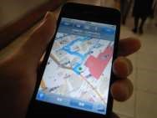

Navigation

System

Central

Cloud

Server

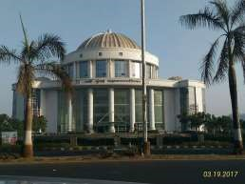

Municipal

Corporation

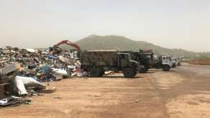

Garbage



sensor



➢

GPS Module

➢

Arduino Uno

➢

GSM Module

GGTFGFRYYUGHJGG

➢

➢

➢